## Front End Engineering-II

Project Report

Semester-IV (Batch-2022)

The Spacious Furniture Website

**Supervised By: Submitted By:**

Raveesh Samkaria Yajat Dureja

2210990970

G-14

**Department of Computer Science and Engineering**

## Chitkara University Institute of Engineering & Technology,

## Chitkara University, Punjab

## Abstract

## The abstract provides a comprehensive overview of "The Spacious" website, showcasing its innovative implementation of modern HTML techniques to craft an aesthetically pleasing and user-centric interface. Centered around the theme of furniture and interior design, the website offers a diverse array of products and services tailored to meet the varying needs of its clientele. Its commitment to responsive design ensures optimal accessibility and functionality across a wide range of devices, from traditional desktop computers to the increasingly prevalent mobile platforms, thereby enriching the browsing experience for users. By placing a strong emphasis on adaptability, the abstract underscores the paramount importance of responsive design in facilitating seamless interaction and engagement across diverse digital environments, reinforcing the website's position as a premier destination for furniture enthusiasts and design lovers alike.

## Introduction:

This report documents the development process of "The Spacious" website, focusing on creating a responsive and visually appealing online platform for a furniture and interior agency. The website aims to showcase featured categories, the latest interior products, and blog posts while providing an intuitive user experience across various devices.

**Development Process:**

The development process involved several key stages:

**HTML Structure:**

Created the HTML structure with semantic markup to ensure accessibility and SEO-friendliness.

Organized sections such as navigation, search, welcome message, featured categories, our story, latest products, blog, newsletter, and footer.

**CSS Styling:**

Utilized CSS for styling, layout, and responsiveness.

Implemented a responsive grid system to ensure consistent layout across different screen sizes.

Styled navigation, search bar, welcome section, categories, our story, latest products, blog section, newsletter, and footer for visual coherence.

Used CSS Flexbox and Grid for layout structuring and alignment.

**Responsive Design:**

Employed media queries to create breakpoints for adjusting layout and styling based on screen size.

Ensured fluidity and adaptability of elements to accommodate various viewport dimensions.

Optimized images and content layout for different devices, including mobile phones, tablets, and desktops.

**Interactive Elements:**

Implemented interactive elements such as buttons and hover effects for enhanced user engagement.

Integrated font icons for social media links and cart icons.

**Content Integration:**

Integrated placeholder content and images to simulate the presentation of furniture categories, blog posts, and newsletter subscriptions.

**Optimization:**

Optimized performance by minifying CSS, optimizing images, and leveraging browser caching.

Ensured fast loading times and smooth user interactions across devices.

**Challenges Faced:**

Achieving consistent design aesthetics across different screen sizes while maintaining responsiveness.

Balancing aesthetics with performance optimization, especially with large images and media assets.

Ensuring compatibility and responsiveness across various web browsers and devices.

**Conclusion:**

The development of "The Spacious" website focused on creating a responsive and visually appealing online platform for a furniture and interior agency. By employing modern web development techniques, including HTML, CSS, and responsive design principles, the website offers a seamless user experience across devices. Further refinements and optimizations can be made based on user feedback and evolving design trends to continuously improve the website's functionality and user experience.

**Future Recommendations:**

Incorporate dynamic content loading to improve initial page load times, especially for image-heavy sections.

Implement accessibility features to ensure compliance with WCAG standards and enhance inclusivity.

Integrate backend functionality for dynamic content management, user authentication, and e-commerce capabilities if required.

**Problem Definition:**

The problem at hand involves creating a responsive website for "The Spacious," a furniture and interior agency, to showcase their products and services online. The primary aim is to provide an engaging and visually appealing platform that effectively presents furniture categories, latest products, blog posts, and other relevant information to potential customers. The website should be accessible across various devices, including desktops, tablets, and mobile phones, ensuring a seamless user experience regardless of screen size.

**Software Requirements:**

**Code Editor**: A text editor or integrated development environment (IDE) for writing and editing HTML, CSS, and JavaScript code. Examples include Visual Studio Code, Sublime Text, Atom, or JetBrains WebStorm.

**Web Browser**: A modern web browser for testing and previewing the website during development. Popular choices include Google Chrome, Mozilla Firefox, Safari, and Microsoft Edge.

**Version Control System (Optional):** Optionally, a version control system such as Git for managing project versions, collaborating with team members, and tracking changes.

**Image Editing Software:** Software for editing and optimizing images used on the website. Examples include Adobe Photoshop, GIMP, or online tools like Canva or Pixlr.

**Graphics Software (Optional):** Graphics software for creating custom graphics, icons, and visual elements. Examples include Adobe Illustrator, Sketch, or Figma.

**Responsive Design Testing Tools:** Tools for testing the responsiveness of the website across various devices and screen sizes. Examples include Chrome Developer Tools, Firefox Responsive Design Mode, or online services like BrowserStack or Responsinator.

**Hardware Requirements:**

**Computer:** A desktop or laptop computer capable of running the required software tools. The computer should have sufficient processing power and memory to handle web development tasks effectively.

**Display:** A monitor or display screen with adequate resolution for designing and testing responsive layouts. It's beneficial to have multiple displays or a widescreen monitor for efficient multitasking.

**Input Devices**: A keyboard and mouse (or trackpad) for inputting commands, navigating code, and interacting with software tools.

**Internet Connection:** A reliable internet connection for accessing online resources, testing website functionality, and collaborating with team members (if applicable).

**Mobile Devices (Optional):** Optional but recommended for testing the website's responsiveness on mobile devices. This may include smartphones and tablets with various screen sizes and operating systems.

By meeting these software and hardware requirements, developers can effectively design, develop, and test the responsive website for "The Spacious" furniture and interior agency, ensuring a high-quality user experience across different devices and platforms.

**Proposed Design and Methodology:**

**Schematic:**

The website for "The Spacious" will be built using HTML, CSS, and JavaScript, following a responsive design approach to ensure compatibility across various devices and screen sizes. Below is a schematic illustrating the basic structure and components of the website:

assets folder Contains images etc. for the website

index.html Main Html file

styles.css CSS for the website

responsive.css Responsive CSS/media queries for mobile device

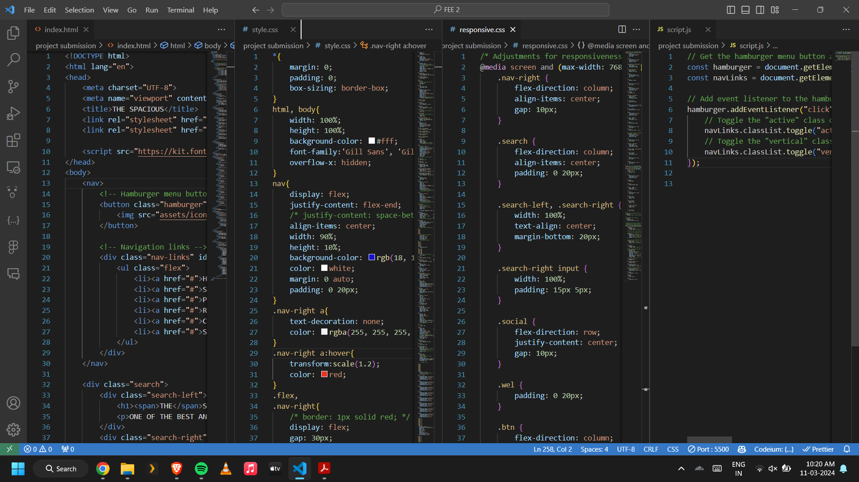

**Results:**

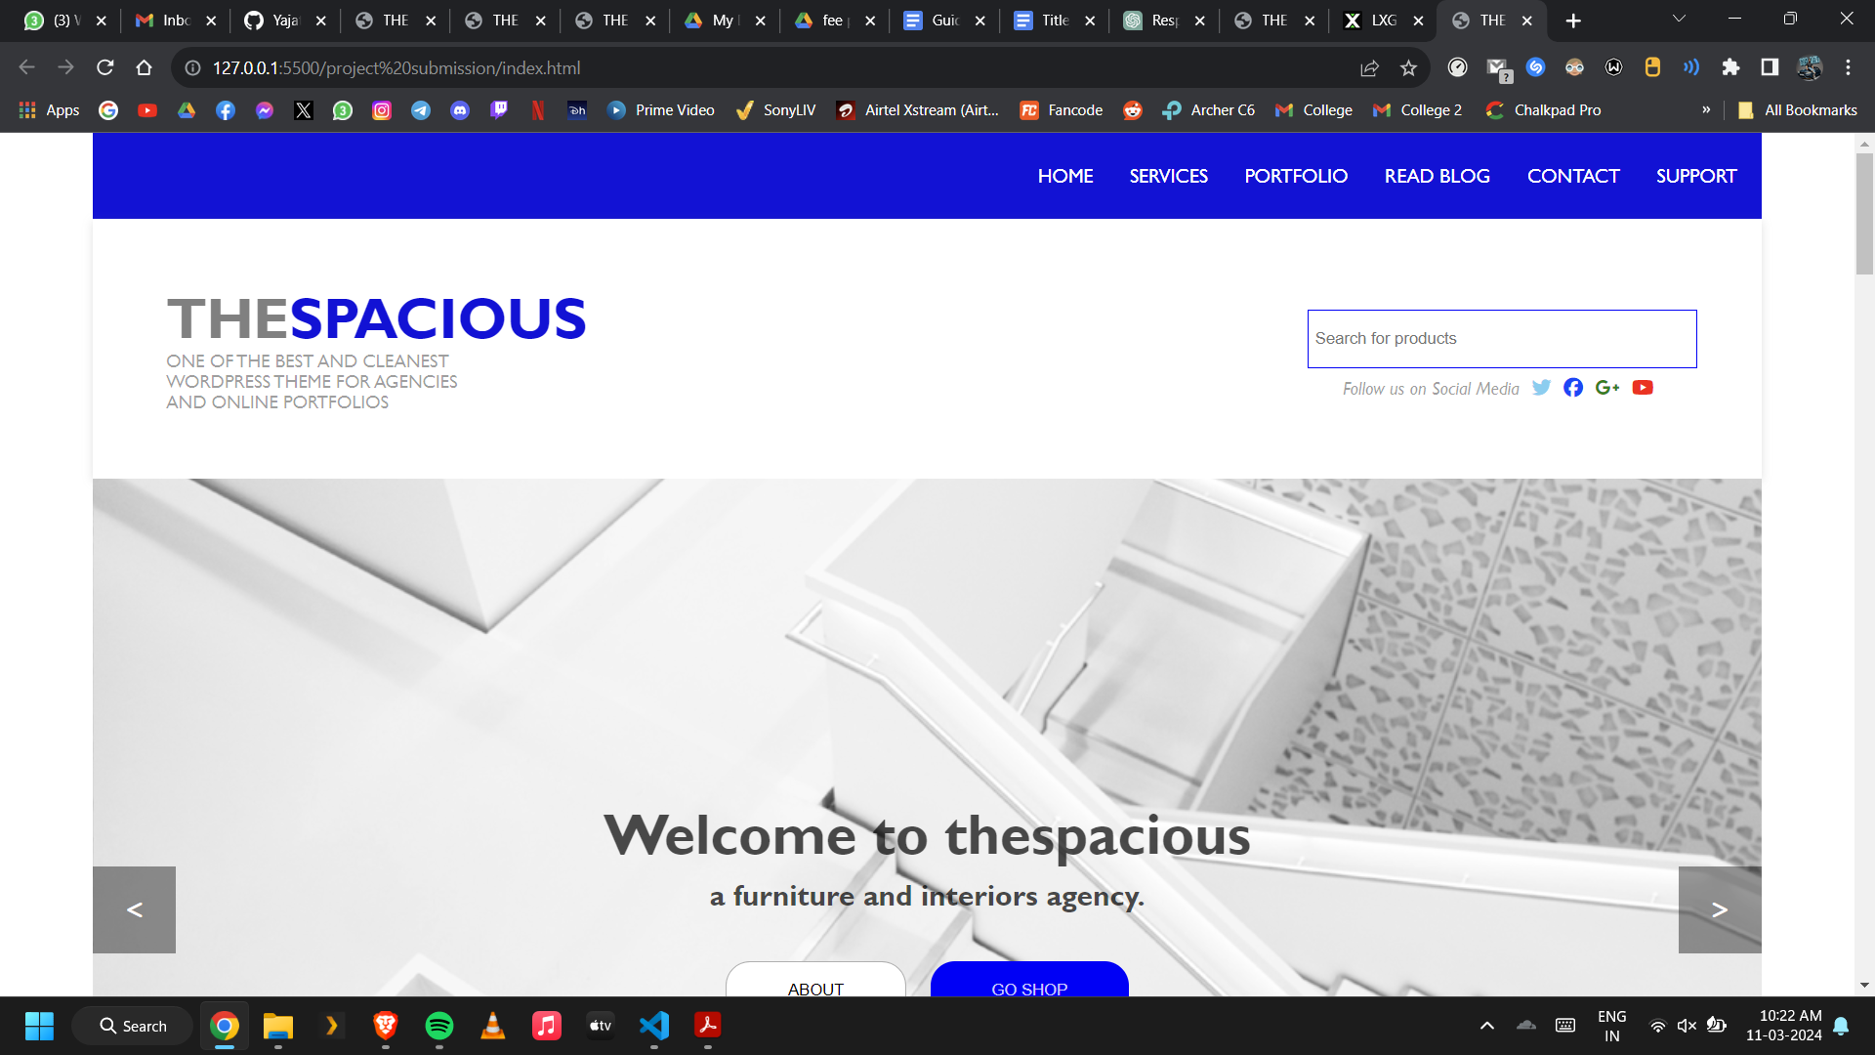

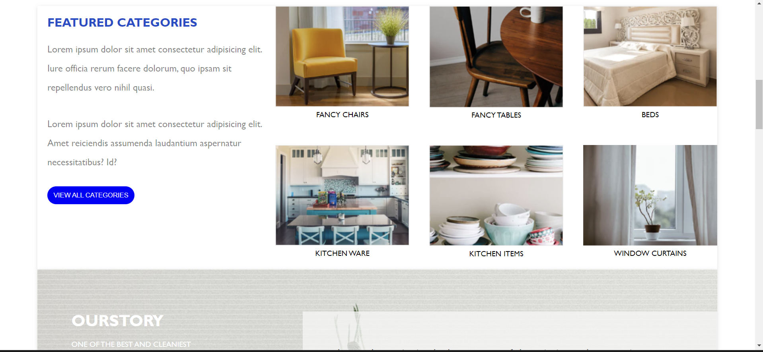

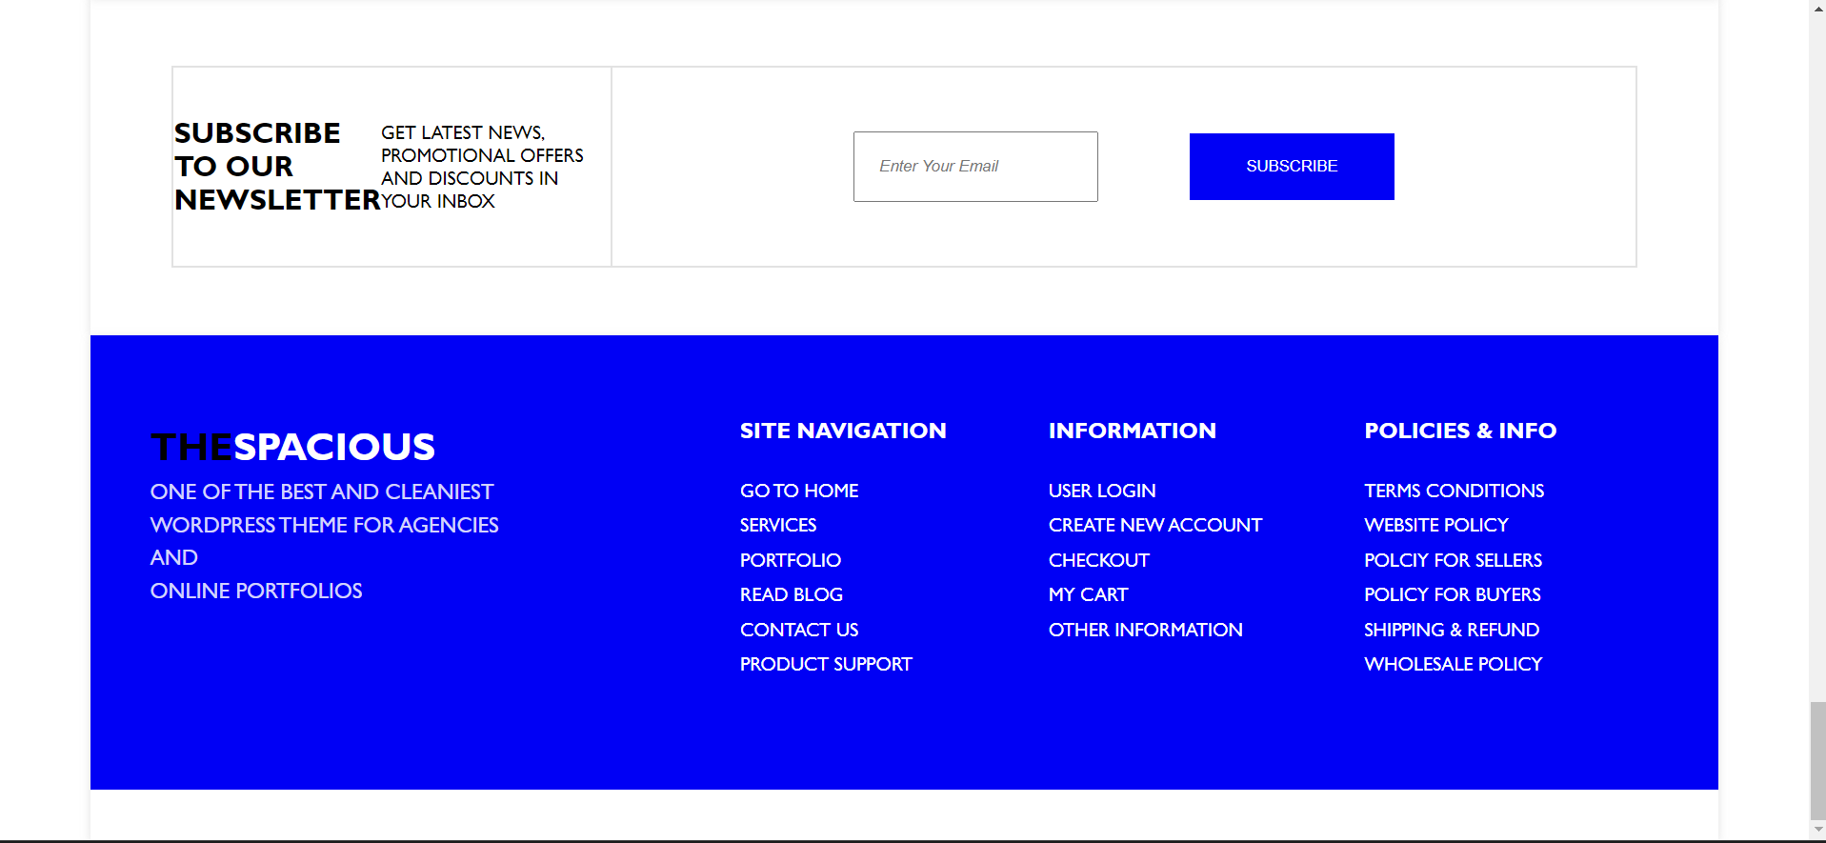

**Media** 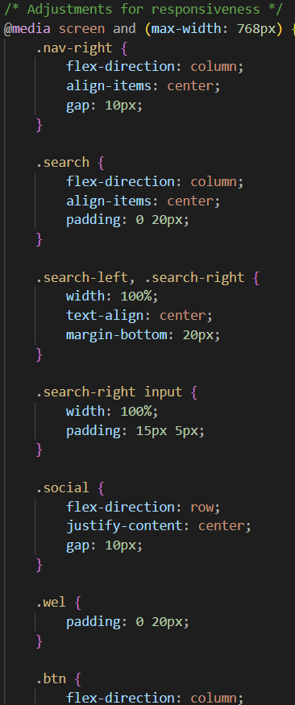

**Queries**

**Responsive Design For Mobile Devices:  
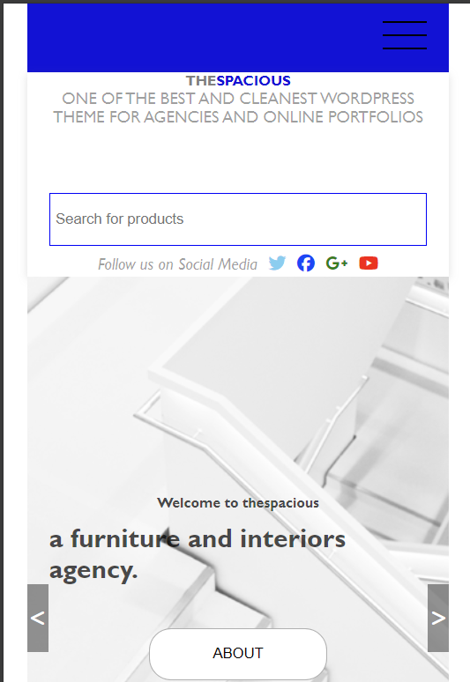**

**Responsive Navbar Using JavaScript and Media Queries**

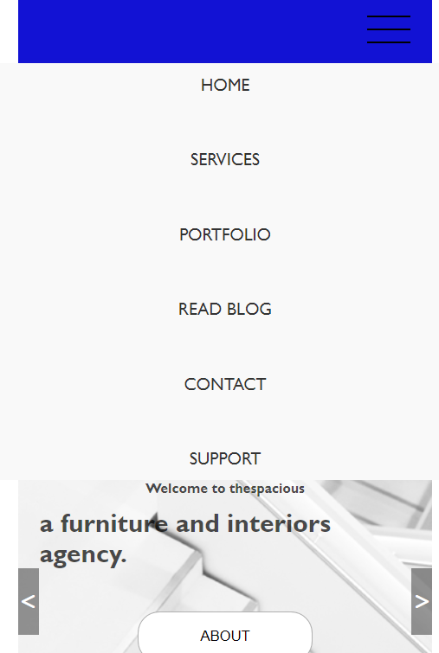

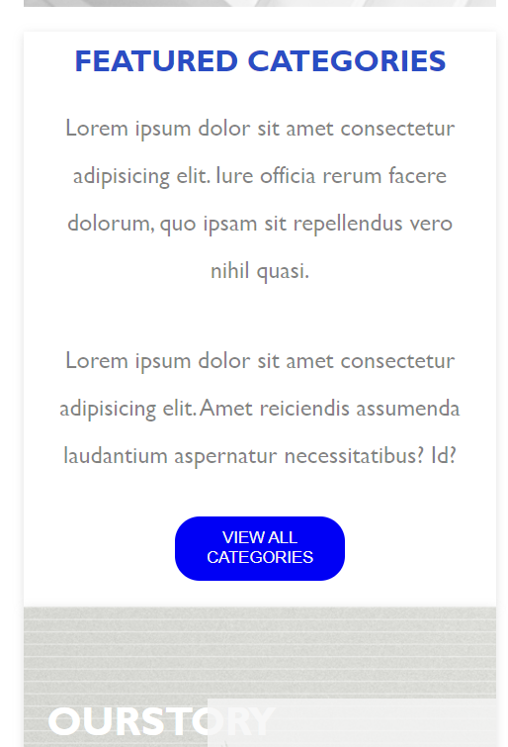

**Basic JavaScript for Navbar**

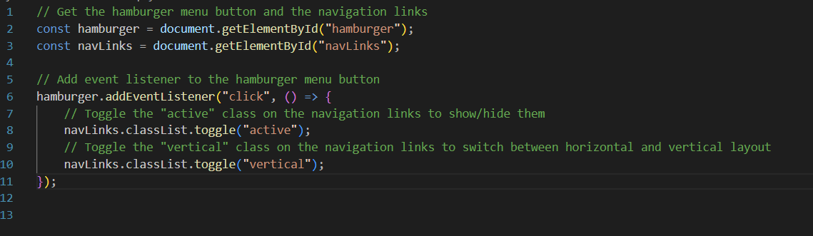

**Media Query For Navbar**

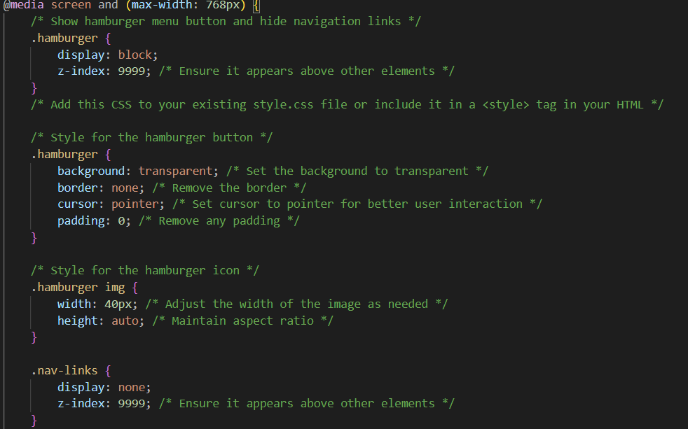

**Complete code:-**

**<!DOCTYPE html>**

**<html lang="en">**

**<head>**

**<meta charset="UTF-8">**

**<meta name="viewport" content="width=device-width, initial-scale=1.0">**

**<title>THE SPACIOUS</title>**

**<link rel="stylesheet" href="style.css">**

**<link rel="stylesheet" href="responsive.css">**

**<script src="https://kit.fontawesome.com/7922fb919e.js" crossorigin="anonymous"></script>**

**</head>**

**<body>**

**<nav>**

**<!-- Hamburger menu button -->**

**<button class="hamburger" id="hamburger">**

**<img src="assets/icons8-hamburger-menu.svg" alt="hamburger menu">**

**</button>**

**<!-- Navigation links -->**

**<div class="nav-links" id="navLinks">**

**<ul class="flex">**

**<li><a href="#">HOME</a></li>**

**<li><a href="#">SERVICES</a></li>**

**<li><a href="#">PORTFOLIO</a></li>**

**<li><a href="#">READ BLOG</a></li>**

**<li><a href="#">CONTACT</a></li>**

**<li><a href="#">SUPPORT</a></li>**

**</ul>**

**</div>**

**</nav>**

**<div class="search">**

**<div class="search-left">**

**<h1><span>THE</span>SPACIOUS</h1>**

**<p>ONE OF THE BEST AND CLEANEST WORDPRESS THEME FOR AGENCIES AND ONLINE PORTFOLIOS</p>**

**</div>**

**<div class="search-right">**

**<input type="text" placeholder="Search for products">**

**<div class="social">**

**<p><i>Follow us on Social Media</i></p>**

**<i class="fa-brands fa-twitter"></i>**

**<i class="fa-brands fa-facebook"></i>**

**<i class="fa-brands fa-google-plus-g"></i>**

**<i class="fa-brands fa-youtube"></i>**

**</div>**

**</div>**

**</div>**

**<div class="welcome">**

**<div class="wel">**

**<div class="great">**

**<i class="fa-solid fa-greater-than"></i>**

**</div>**

**<div class="less">**

**<i class="fa-solid fa-less-than"></i>**

**</div>**

**<h1>Welcome to thespacious</h1>**

**<h3>a furniture and interiors agency.</h3>**

**<div class="btn">**

**<button>ABOUT</button>**

**<button>GO SHOP</button>**

**</div>**

**</div>**

**</div>**

**<div class="categories">**

**<div class="cat-left">**

**<div class="clup">**

**<h2>FEATURED CATEGORIES</h2>**

**<p>Lorem ipsum dolor sit amet consectetur adipisicing elit. Iure officia rerum facere dolorum, quo ipsam sit repellendus vero nihil quasi.</p>**

**</div>**

**<div class="cldown">**

**<p>Lorem ipsum dolor sit amet consectetur adipisicing elit. Amet reiciendis assumenda laudantium aspernatur necessitatibus? Id?</p>**

**<button class="cat-btn">VIEW ALL CATEGORIES</button>**

**</div>**

**</div>**

**<div class="cat-right">**

**<div class="div1">**

**<img src="assets/chairs.png" alt="">**

**<p>FANCY CHAIRS</p>**

**</div>**

**<div class="div2">**

**<img src="assets/tables.png" alt="">**

**<p>FANCY TABLES</p>**

**</div>**

**<div class="div3">**

**<img src="assets/beds (2).png" alt="">**

**<p>BEDS</p>**

**</div>**

**<div class="div4">**

**<img src="assets/kitchenware.png" alt="">**

**<p>KITCHEN WARE</p>**

**</div>**

**<div class="div5">**

**<img src="assets/kitchen-items.png" alt="">**

**<p>KITCHEN ITEMS</p>**

**</div>**

**<div class="div6">**

**<img src="assets/curtains.png" alt="">**

**<p>WINDOW CURTAINS</p>**

**</div>**

**</div>**

**</div>**

**<div class="our">**

**<div class="ourstory">**

**<div class="our-l">**

**<h1>OURSTORY</h1>**

**<h5>ONE OF THE BEST AND CLEANIEST WORDPRESS THEME FOR AGENCIES AND ONLINE PORTFOLIOS</h5>**

**<button>READ MORE+</button>**

**</div>**

**<div class="our-r">**

**<p>Lorem Ipsum is simply dummy text of the printing and typesetting industry. Lorem Ipsum has been the industry's standard dummy text ever since the 1500s, when an unknown printer took a galley of type and scrambled it to make a type specimen book. It has survived not only five centuries, but also the leap into electronic typesetting, remaining essentially unchanged. It was popularised in the 1960s with the release of Letraset sheets containing Lorem Ipsum passages, and more recently with desktop publishing software like Aldus PageMaker including versions of Lorem Ipsum.**

**</p>**

**</div>**

**</div>**

**</div>**

**<div class="latest">**

**<h2 class="lt-prod">LATEST INTERIOR PRODUCTS ADDED</h2>**

**<p class="lt-para">Lorem ipsum is simply dummy text of the printing and typeset <br>ing industry. Lorem ipsum has been the industry's...</p>**

**</div>**

**<div class="grid-container">**

**<div class="grid">**

**<div class="img-1">**

**<div class="p">**

**<p>$45,00</p>**

**</div>**

**<i class="fa-solid fa-cart-shopping"></i>**

**</div>**

**<div class="img-2">**

**<div class="p">**

**<p>$45,00</p>**

**</div>**

**<i class="fa-solid fa-cart-shopping"></i>**

**</div>**

**<div class="img-3">**

**<div class="p">**

**<p>$45,00</p>**

**</div>**

**<i class="fa-solid fa-cart-shopping"></i>**

**</div>**

**<div class="img-4">**

**<div class="p">**

**<p>$45,00</p>**

**</div>**

**<i class="fa-solid fa-cart-shopping"></i>**

**</div>**

**<div class="img-5">**

**<div class="p">**

**<p>$45,00</p>**

**</div>**

**<i class="fa-solid fa-cart-shopping"></i>**

**</div>**

**<div class="img-6">**

**<div class="p">**

**<p>$45,00</p>**

**</div>**

**<i class="fa-solid fa-cart-shopping"></i>**

**</div>**

**<div class="img-7">**

**<div class="p">**

**<p>$45,00</p>**

**</div>**

**<i class="fa-solid fa-cart-shopping"></i>**

**</div>**

**<div class="img-8">**

**<div class="p">**

**<p>$45,00</p>**

**</div>**

**<i class="fa-solid fa-cart-shopping"></i>**

**</div>**

**<div class="img-9">**

**<div class="p">**

**<p>$45,00</p>**

**</div>**

**<i class="fa-solid fa-cart-shopping"></i>**

**</div>**

**</div>**

**</div>**

**<div class="view">**

**<button>VIEW MORE</button>**

**</div>**

**<div class="blog">**

**<div class="blogging">**

**<img src="assets/Layer 32.png" alt="">**

**<div class="blog-lt">**

**<h1 class="blog-h">READ OUR BLOG</h1>**

**<h5 class="blot-t">ONE OF THE BEST AND CLEANIEST <br> WORDPRESS THEME FOR AGENCIES <br> AND ONLINE PORTFOLIOS</h5>**

**</div>**

**<div class="blog-rt">**

**<div class="rt-l">**

**<img src="assets/Layer 35.png" alt="">**

**<p>SOME OF THE BEST FURNITURE <br> DESIGNS OF THE YEAR 2024</p>**

**<button class="more">+MORE</button>**

**</div>**

**<div class="rt-r">**

**<img src="assets/Layer 36.png" alt="">**

**<p>SOME OF THE BEST FURNITURE <br> DESIGNS OF THE YEAR 2024</p>**

**<button>+MORE</button>**

**</div>**

**</div>**

**</div>**

**</div>**

**<div class="newsletter">**

**<div class="news">**

**<div class="news-one">**

**<h2>SUBSCRIBE TO OUR NEWSLETTER</h2>**

**<p>GET LATEST NEWS, PROMOTIONAL OFFERS AND DISCOUNTS IN YOUR INBOX</p>**

**</div>**

**<div class="news-two">**

**<input type="text" placeholder="Enter Your Email">**

**<button>SUBSCRIBE</button>**

**</div>**

**</div>**

**</div>**

**<div class="footer">**

**<div class="ft-top">**

**<div class="ft-lt">**

**<h1><span>THE</span>SPACIOUS</h1>**

**<p>ONE OF THE BEST AND CLEANIEST <br> WORDPRESS THEME FOR AGENCIES AND <br> ONLINE PORTFOLIOS</p>**

**</div>**

**<div class="ft-rt">**

**<div class="rt-1">**

**<h5 class="fth">SITE NAVIGATION</h5>**

**<div class="paras">**

**<p>GO TO HOME</p>**

**<p>SERVICES</p>**

**<p>PORTFOLIO</p>**

**<p>READ BLOG</p>**

**<p>CONTACT US</p>**

**<p>PRODUCT SUPPORT</p>**

**</div>**

**</div>**

**<div class="rt-2">**

**<h5 class="fth">INFORMATION</h5>**

**<div class="paras">**

**<p>USER LOGIN</p>**

**<p>CREATE NEW ACCOUNT</p>**

**<p>CHECKOUT</p>**

**<p>MY CART</p>**

**<p>OTHER INFORMATION</p>**

**</div>**

**</div>**

**<div class="rt-3">**

**<h5 class="fth">POLICIES & INFO</h5>**

**<div class="paras">**

**<p>TERMS CONDITIONS</p>**

**<p>WEBSITE POLICY</p>**

**<p>POLCIY FOR SELLERS</p>**

**<p>POLICY FOR BUYERS</p>**

**<p>SHIPPING & REFUND</p>**

**<p>WHOLESALE POLICY</p>**

**</div>**

**</div>**

**</div>**

**</div>**

**<script src="script.js"></script>**

**</body>**

**</html>**

**\*{**

**margin: 0;**

**padding: 0;**

**box-sizing: border-box;**

**}**

**html, body{**

**width: 100%;**

**height: 100%;**

**background-color: #fff;**

**font-family:'Gill Sans', 'Gill Sans MT', Calibri, 'Trebuchet MS', sans-serif;**

**overflow-x: hidden;**

**}**

**nav{**

**display: flex;**

**justify-content: flex-end;**

**/* justify-content: space-between; */**

**align-items: center;**

**width: 90%;**

**height: 10%;**

**background-color: rgb(18, 18, 221);**

**color: white;**

**margin: 0 auto;**

**padding: 0 20px;**

**}**

**.nav-right a{**

**text-decoration: none;**

**color: rgba(255, 255, 255, 0.94);**

**}**

**.nav-right a:hover{**

**transform:scale(1.2);**

**color: red;**

**}**

**.flex,**

**.nav-right{**

**/* border: 1px solid red; */**

**display: flex;**

**gap: 30px;**

**}**

**nav h3{**

**font-size: 1rem;**

**font-weight: 200;**

**}**

**.search{**

**background-color: white;**

**padding: 0 60px;**

**display: flex;**

**align-items: center;**

**justify-content: space-between;**

**width: 90%;**

**margin: 0 auto;**

**height: 30%;**

**box-shadow: rgba(99, 99, 99, 0.2) 0px 2px 8px 0px;**

**/* border: 1px solid black; */**

**}**

**.search h1 span{**

**color: gray;**

**}**

**.search h1{**

**font-size: 3vw;**

**color: rgb(18, 18, 221);**

**}**

**.search p{**

**font-size: 0.94em;**

**color: rgba(0, 0, 0, 0.377);**

**}**

**.search-left{**

**/* border: 1px solid black; */**

**width: 20%;**

**}**

**.search-right{**

**/* border: 1px solid black; */**

**width: 25%;**

**height: 30%;**

**}**

**.search-right input{**

**border: 1px solid blue;**

**padding: 15px 150px 15px 5px;**

**outline: none;**

**}**

**.social{**

**margin-top: 8px;**

**display: flex;**

**align-items: flex-center;**

**justify-content: center;**

**gap: 10px;**

**}**

**.social i:nth-child(2){**

**color: rgb(119, 207, 243);**

**}**

**.social i:nth-child(3){**

**color: rgb(0, 72, 255);**

**}**

**.social i:nth-child(4){**

**color: green;**

**}**

**.social i:nth-child(5){**

**color: red;**

**}**

**.welcome{**

**width: 90%;**

**margin: 0 auto;**

**height: 100%;**

**color: rgba(0, 0, 0, 0.701);**

**/* background-color: black; */**

**}**

**.wel{**

**position: relative;**

**/* margin: auto auto; */**

**background-image: url(assets/Layer\ 6.png);**

**background-position: center;**

**background-size:cover;**

**display: flex;**

**flex-direction: column;**

**justify-content: center;**

**align-items: center;**

**height: 100%;**

**width: 100%;**

**gap: 10px;**

**/* border: 1px solid red; */**

**}**

**.welcome h1{**

**font-size: 3vw;**

**}**

**.welcome h3{**

**font-size: 1.5em;**

**}**

**.welcome button{**

**padding: 15px 50px;**

**border-radius: 20px;**

**border: none;**

**}**

**.welcome button:nth-child(1){**

**background-color: white;**

**color: black;**

**border: 1px solid rgba(0, 0, 0, 0.31);**

**}**

**.welcome button:nth-child(2){**

**background-color: blue;**

**color: rgba(255, 255, 255, 0.796);**

**}**

**.btn{**

**display: flex;**

**margin-top: 30px;**

**gap: 20px;**

**}**

**.great{**

**position: absolute;**

**right: 0;**

**width: 5%;**

**height: 10%;**

**background-color: rgba(0, 0, 0, 0.407);**

**color: white;**

**display: flex;**

**align-items: center;**

**justify-content: center;**

**/* justify-content: space-around; */**

**/* text-align: center; */**

**}**

**.less{**

**position: absolute;**

**left: 0;**

**width: 5%;**

**height: 10%;**

**background-color: rgba(0, 0, 0, 0.407);**

**color: white;**

**display: flex;**

**align-items: center;**

**justify-content: center;**

**/* justify-content: space-around; */**

**/* text-align: center; */**

**}**

**.categories{**

**/* margin-top: 20px; */**

**display: flex;**

**margin: 10vh auto 0 auto;**

**width: 90%;**

**height: 75%;**

**box-shadow: rgba(99, 99, 99, 0.2) 0px 2px 8px 0px;**

**}**

**.cat-left{**

**line-height: 2;**

**padding: 10px 20px;**

**display: flex;**

**flex-direction: column;**

**width: 35%;**

**height: 100%;**

**/* border: 1px solid black; */**

**}**

**.cat-right{**

**display: grid;**

**grid-template-columns: 1fr 1fr 1fr;**

**grid-auto-rows: 1fr 1fr;**

**column-gap: 40px;**

**row-gap: 30px;**

**width: 65%;**

**height: 100%;**

**/* border: 1px solid black; */**

**}**

**.div1,**

**.div2,**

**.div3,**

**.div4,**

**.div5,**

**.div6{**

**/* border: 1px solid red; */**

**width: 100%;**

**text-align: center;**

**font-size: 1vw;**

**font-weight: 500;**

**color: black;**

**/* padding-top: 10px; */**

**}**

**.div1 p,**

**.div2 p,**

**.div3 p,**

**.div4 p,**

**.div5 p,**

**.div6 p{**

**padding-top: 3px;**

**}**

**.div1 img,**

**.div2 img,**

**.div3 img,**

**.div4 img,**

**.div5 img,**

**.div6 img{**

**/* border: 1px solid red; */**

**width: 100%;**

**}**

**.clup h2{**

**color: rgb(28, 78, 203);**

**}**

**.cat-left p{**

**font-size: 1.2em;**

**color: rgba(0, 0, 0, 0.49);**

**}**

**.clup{**

**display: flex;**

**flex-direction: column;**

**gap: 10px;**

**}**

**.cldown{**

**margin-top: 35px;**

**display: flex;**

**flex-direction: column;**

**gap: 30px;**

**}**

**.cldown button{**

**background-color: blue;**

**color: whitesmoke;**

**padding: 10px 10px;**

**width: 40%;**

**border-radius: 20px;**

**border: none;**

**}**

**.our{**

**width: 90%;**

**height: 80%;**

**margin: 0 auto;**

**box-shadow: rgba(99, 99, 99, 0.2) 0px 2px 8px 0px;**

**background-image: url(assets/Layer\ 18.png);**

**background-size: cover;**

**background-position: center;**

**}**

**.ourstory{**

**position: relative;**

**height: 100%;**

**width: 100%;**

**background-image: url(assets/Layer\ 17.png);**

**opacity: 1;**

**}**

**.our-l{**

**position: absolute;**

**left: 5%;**

**top: 15%;**

**display: flex;**

**flex-direction: column;**

**gap: 20px;**

**color: white;**

**width: 21%;**

**}.our-l h5{**

**font-weight: 300;**

**font-size: 1vw;**

**}**

**.our-l button{**

**width: 60%;**

**background-color: #fff;**

**color: black;**

**padding: 10px 35px;**

**border-radius: 20px;**

**border: none;**

**}**

**.our-r{**

**display: flex;**

**padding: 70px;**

**position: absolute;**

**right: 0;**

**top: 15%;**

**width: 61%;**

**height: 70%;**

**background-color: rgba(245, 245, 245, 0.796);**

**font-size: 1.5vw;**

**color: rgba(0, 0, 0, 0.585);**

**/* opacity: 1; */**

**}**

**.our-r p{**

**z-index: 100;**

**}**

**.latest{**

**width: 90%;**

**height: 25%;**

**display: flex;**

**flex-direction: column;**

**justify-content: center;**

**align-items: center;**

**padding-top: 20px;**

**/* border: 1px solid black; */**

**box-shadow: rgba(99, 99, 99, 0.2) 0px 2px 8px 0px;**

**margin: 0 auto;**

**text-align: center;**

**line-height: 2;**

**}**

**.latest h2{**

**font-size: 2vw;**

**color: rgb(13, 60, 233);**

**}**

**.latest p{**

**font-size: 1.3vw;**

**}**

**.grid-container{**

**margin-top: 10vh;**

**width: 90%;**

**box-shadow: rgba(99, 99, 99, 0.2) 0px 2px 8px 0px;**

**height: 150vh;**

**/* border: 1px solid black; */**

**margin: 0 auto;**

**}**

**.grid{**

**width: 95%;**

**height: 100%;**

**/* background-color: red; */**

**margin: 0 auto;**

**display: grid;**

**grid-template-columns: repeat(3, 1fr);**

**grid-template-rows: repeat(3, 1fr);**

**column-gap: 4vw;**

**/* row-gap: 2vw; */**

**}**

**.img-1,**

**.img-2,**

**.img-3,**

**.img-4,**

**.img-5,**

**.img-6,**

**.img-7,**

**.img-8,**

**.img-9{**

**position: relative;**

**/* border: 1px solid green; */**

**margin-bottom: 8vh;**

**}**

**.img-1, .img-9{**

**background-image: url(assets/chair-one.png);**

**background-repeat: no-repeat;**

**background-size: cover;**

**background-position: center;**

**}**

**.img-2{**

**background-image: url(assets/coffee.png);**

**background-repeat: no-repeat;**

**background-size: cover;**

**background-position: center;**

**}**

**.img-3{**

**background-image: url(assets/curtain.png);**

**background-repeat: no-repeat;**

**background-size: cover;**

**background-position: center;**

**}**

**.img-4{**

**background-image: url(assets/curtain-two.png);**

**background-repeat: no-repeat;**

**background-size: cover;**

**background-position: center;**

**}**

**.img-5{**

**background-image: url(assets/curtain-three.png);**

**background-repeat: no-repeat;**

**background-size: cover;**

**background-position: center;**

**}**

**.img-6{**

**background-image: url(assets/curtain-four.png);**

**background-repeat: no-repeat;**

**background-size: cover;**

**background-position: center;**

**}**

**.img-7{**

**background-image: url(assets/curtain-five.png);**

**background-repeat: no-repeat;**

**background-size: cover;**

**background-position: center;**

**}**

**.img-8{**

**background-image: url(assets/curtain.png);**

**background-repeat: no-repeat;**

**background-size: cover;**

**background-position: center;**

**}**

**.img-1 .p,**

**.img-2 .p,**

**.img-3 .p,**

**.img-4 .p,**

**.img-5 .p,**

**.img-6 .p,**

**.img-7 .p,**

**.img-8 .p,**

**.img-9 .p{**

**position: absolute;**

**background-color: rgba(0, 69, 189, 0.784);**

**width: 17%;**

**height: 15%;**

**color: white;**

**right: 0%;**

**display: flex;**

**align-items: center;**

**justify-content: center;**

**flex-direction: column;**

**}**

**.img-1 i,**

**.img-2 i,**

**.img-3 i,**

**.img-4 i,**

**.img-5 i,**

**.img-6 i,**

**.img-7 i,**

**.img-8 i,**

**.img-9 i{**

**position: absolute;**

**background-color: rgba(0, 69, 189, 0.463);**

**width: 17%;**

**height: 15%;**

**color: white;**

**right: 0%;**

**top: 15%;**

**display: flex;**

**align-items: center;**

**justify-content: center;**

**flex-direction: column;**

**}**

**.view{**

**width: 90%;**

**margin: 0 auto;**

**height: 20%;**

**display: flex;**

**justify-content: center;**

**/* box-shadow: rgba(99, 99, 99, 0.2) 0px 2px 8px 0px; */**

**align-items: center;**

**}**

**.view button{**

**width: 15%;**

**height: 35%;**

**border-radius: 30px;**

**border: none;**

**background-color:rgb(26, 26, 235);**

**color: white;**

**}**

**.blog{**

**display: flex;**

**box-shadow: rgba(99, 99, 99, 0.2) 0px 0px 8px 0px;**

**width: 90%;**

**height: 80%;**

**/* background-color: white; */**

**margin: 0 auto;**

**/* background-image: url(assets/Layer\ 32.png); */**

**/* opacity: 40%; */**

**}**

**.blogging{**

**width: 100%;**

**height: 100%;**

**position: relative;**

**}**

**.blogging >img{**

**opacity: 60%;**

**width: 100%;**

**height: 100%;**

**}**

**.blog-lt{**

**width: 30%;**

**position: absolute;**

**top: 12%;**

**left: 10%;**

**/* border: 1px solid red; */**

**/* margin-top: 8vh; */**

**line-height: 2;**

**}**

**.blog-rt{**

**width: 65%;**

**height: 80%;**

**position: absolute;**

**top: 12%;**

**right: 0%;**

**display: flex;**

**/* border: 1px solid red; */**

**/* margin-top: 8vh; */**

**}**

**.rt-l img,**

**.rt-r img{**

**width: 90%;**

**height: 70%;**

**}**

**.rt-l,**

**.rt-r{**

**display: flex;**

**flex-direction: column;**

**gap: 20px;**

**height: 100%;**

**width: 50%;**

**/* border: 1px solid black; */**

**padding-left: 10px;**

**}**

**.rt-r{**

**height: 100%;**

**width: 50%;**

**/* border: 1px solid black; */**

**}**

**.blog-rt button{**

**width: 25%;**

**height: 7%;**

**border: none;**

**border-radius: 5px;**

**color: white;**

**background-color: blue;**

**}**

**.newsletter{**

**width: 90%;**

**height: 40%;**

**margin: 0 auto;**

**/* border: 1px solid black; */**

**box-shadow: rgba(99, 99, 99, 0.2) 0px 0px 8px 0px;**

**display: flex;**

**justify-content: center;**

**align-items: center;**

**}**

**.news{**

**display: flex;**

**height: 60%;**

**width: 90%;**

**/* border: 1px solid black; */**

**border: 0.5px solid rgba(0, 0, 0, 0.114);**

**}**

**.news-one{**

**display: flex;**

**justify-content: center;**

**align-items: center;**

**width: 30%;**

**height: 100%;**

**border: 0.5px solid rgba(0, 0, 0, 0.114);**

**}**

**.news-two{**

**width: 70%;**

**display: flex;**

**justify-content: center;**

**align-items: center;**

**height: 100%;**

**gap: 5vw;**

**border: 0.5px solid rgba(0, 0, 0, 0.114);**

**/* border: 1px solid black; */**

**}**

**.news-two input{**

**padding: 20px;**

**}**

**.news-two button{**

**padding: 20px;**

**width: 20%;**

**border: none;**

**background-color: blue;**

**color: white;**

**}**

**.news-two input::placeholder{**

**font-style: italic;**

**}**

**.footer{**

**box-shadow: rgba(99, 99, 99, 0.2) 0px 2px 8px 0px;**

**width: 90%;**

**height: 60%;**

**margin: 0 auto;**

**/* border: 1px solid black; */**

**}**

**.ft-top{**

**display: flex;**

**padding-top: 20px;**

**width: 100%;**

**height: 90%;**

**background-color: blue;**

**}**

**.ft-bottom{**

**width: 100%;**

**height: 10%;**

**background-color:black;**

**}**

**.ft-lt{**

**/* border: 1px solid black; */**

**width: 30%;**

**padding: 50px;**

**line-height: 1.5;**

**color: white;**

**}**

**.ft-lt span{**

**color: black;**

**}**

**.ft-lt p{**

**font-size: 1.2vw;**

**color: rgba(255, 255, 255, 0.827);**

**}**

**.ft-rt{**

**padding:50px;**

**width: 70%;**

**/* border: 1px solid black; */**

**display: flex;**

**justify-content: space-evenly;**

**}**

**.ft-rt h5{**

**color: white;**

**font-size: 1.2vw;**

**}**

**.ft-rt p{**

**color: white;**

**}**

**.paras{**

**margin-top: 30px;**

**display: flex;**

**flex-direction: column;**

**gap: 10px;**

**}**

**.nav-links ul li a {**

**text-decoration: none;**

**color: white; /* Change color to your desired color */**

**}**

**.nav-links ul {**

**list-style: none;**

**}**

**.nav-links a:hover{**

**color: red;**

**}**

**/* Adjustments for responsiveness */**

**@media screen and (max-width: 768px) {**

**.nav-right {**

**flex-direction: column;**

**align-items: center;**

**gap: 10px;**

**}**

**.search {**

**flex-direction: column;**

**align-items: center;**

**padding: 0 20px;**

**}**

**.search-left, .search-right {**

**width: 100%;**

**text-align: center;**

**margin-bottom: 20px;**

**}**

**.search-right input {**

**width: 100%;**

**padding: 15px 5px;**

**}**

**.social {**

**flex-direction: row;**

**justify-content: center;**

**gap: 10px;**

**}**

**.wel {**

**padding: 0 20px;**

**}**

**.btn {**

**flex-direction: column;**

**gap: 10px;**

**}**

**.categories {**

**flex-direction: column;**

**align-items: center;**

**margin-top: 20px;**

**}**

**.cat-right {**

**display: none;**

**}**

**.cat-left, .cat-right {**

**width: 100%;**

**padding: 0 20px;**

**text-align: center;**

**}**

**.grid-container {**

**margin-top: 20px;**

**}**

**.grid {**

**grid-template-columns: repeat(2, 1fr);**

**column-gap: 3vw;**

**}**

**.img-1, .img-9 {**

**background-size: contain;**

**}**

**.blog {**

**flex-direction: column;**

**align-items: center;**

**margin-top: 20px;**

**}**

**.blog-lt, .blog-rt {**

**width: 100%;**

**text-align: center;**

**}**

**.blog-lt {**

**margin-bottom: 20px;**

**}**

**.blog-rt {**

**flex-direction: column;**

**gap: 20px;**

**}**

**.ourstory {**

**font-size: 16px;**

**}**

**.newsletter, .footer {**

**flex-direction: column;**

**align-items: center;**

**margin-top: 20px;**

**}**

**.news {**

**flex-direction: column;**

**width: 100%;**

**}**

**.news-one, .news-two {**

**width: 100%;**

**text-align: center;**

**margin-bottom: 20px;**

**}**

**.news-two input, .news-two button {**

**width: 100%;**

**}**

**.ft-lt, .ft-rt {**

**width: 100%;**

**text-align: center;**

**}**

**.ft-rt {**

**flex-direction: column;**

**gap: 20px;**

**}**

**.paras {**

**flex-direction: column;**

**gap: 10px;**

**}**

**}**

**/* Adjustments for responsiveness */**

**@media screen and (max-width: 768px) {**

**@media only screen and (max-width: 768px) {**

**/* Hide the "Layer 35" and "Layer 36" images */**

**.blog-rt .rt-l,**

**.blog-rt .rt-r {**

**display: none;**

**}**

**}**

**.blog {**

**flex-direction: column;**

**align-items: center;**

**margin-top: 20px;**

**}**

**.blogging {**

**width: 90%;**

**}**

**.blog-lt {**

**margin-bottom: 20px;**

**}**

**.blog-lt, .blog-rt {**

**width: 100%;**

**text-align: center;**

**}**

**.blog-rt {**

**flex-direction: column;**

**gap: 20px;**

**}**

**.blog-rt img {**

**width: 100%;**

**height: auto;**

**}**

**.blog-rt button {**

**width: 50%;**

**margin: auto;**

**}**

**.rt-l img, .rt-r img {**

**width: 100%;**

**height: auto;**

**}**

**.rt-l, .rt-r {**

**width: 100%;**

**}**

**}**

**/* Hamburger menu button styles */**

**.hamburger {**

**display: none; /* Hide by default */**

**}**

**/* Navigation links styles */**

**.nav-links {**

**display: flex;**

**justify-content: flex-end;**

**}**

**@media screen and (max-width: 768px) {**

**/* Show hamburger menu button and hide navigation links */**

**.hamburger {**

**display: block;**

**z-index: 9999; /* Ensure it appears above other elements */**

**}**

**.hamburger {**

**background: transparent;**

**border: none;**

**cursor: pointer;**

**padding: 0;**

**}**

**/* Style for the hamburger icon */**

**.hamburger img {**

**width: 40px; /* Adjust the width of the image as needed */**

**height: auto; /* Maintain aspect ratio */**

**}**

**.nav-links {**

**display: none;**

**z-index: 9999; /* Ensure it appears above other elements */**

**}**

**/* Show navigation links when the "active" class is present */**

**.nav-links.active {**

**display: flex;**

**flex-direction: column;**

**position: absolute;**

**top: 60px; /* Adjust as needed */**

**right: 0;**

**background-color: #f9f9f9;**

**width: 100%;**

**z-index: 9999;**

**}**

**.nav-links.active ul {**

**padding: 0;**

**}**

**.nav-links.active ul li {**

**padding: 10px;**

**}**

**.nav-links ul li a {**

**text-decoration: none;**

**color: #333;**

**}**

**/* Style for vertical layout */**

**.nav-links.vertical ul {**

**flex-direction: column; /* Ensure vertical layout */**

**align-items: center; /* Center the items vertically */**

**}**

**.cat-btn {**

**align-self: center;**

**}**

**.lt-prod,**

**.lt-para{**

**scale: 150%;**

**}**

**.more {**

**align-self: center;**

**}**

**.ft-top{**

**height: auto;**

**display: flex;**

**flex-direction: column;**

**}**

**.ft-rt h5 {**

**color: white;**

**font-size: 3vw;**

**}**

**.rt-2{**

**margin-top: 50px;**

**}**

**.rt-3{**

**margin-top: 50px;**

**}**

**}**

**@media screen and (max-width: 500px){**

**.ft-rt h5 {**

**color: white;**

**font-size: 5vw;**

**}**

**}**

**References:-**

W3schools

Iconify

FontAwesome